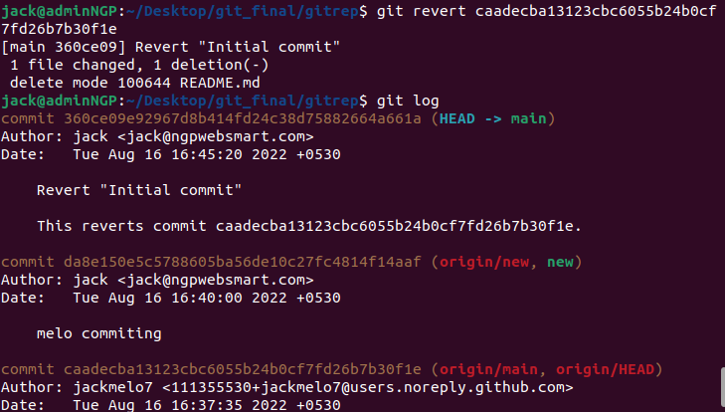
1.Consider a scenario where a person A, made a commit and pushed the files to a remote repository. Later, he/she realized that he/she had made a wrong commit to the remote repository,how can he/she discard the committed changes ?
l
We have a local directory with n number of files and also we have a remote repository, we need to create a branch and push the files from the local directory to remote repository. How can we achieve this ?
2.
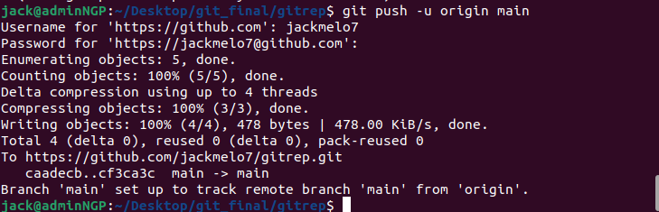
.

3.Consider a scenario where a person A made a commit.Later he realizes that he should make a change in that commit.What should he do to change the commit without reverting the commit?

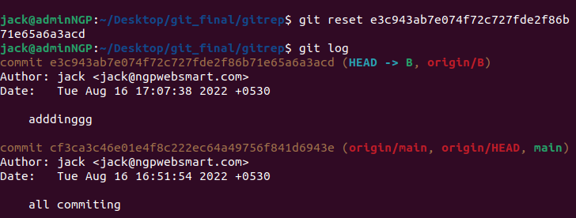
.

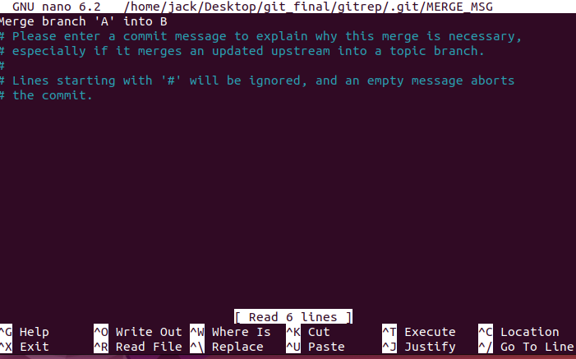
4.Create two branches from master, say branch A and B.We need to make changes in the same file in both branches.(A and B).Now we try to merge the branches A and B, a conflict will arise.How will you solve the conflict?

5.While using VIM editor,a person enters 100 lines.In that he finds 10 continuous lines as error.How could he remove those 10 lines using a single command?
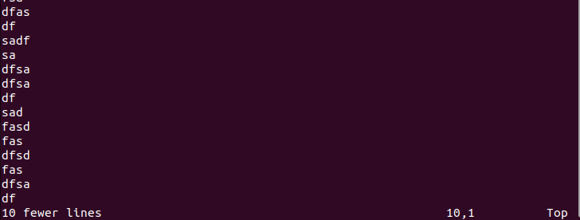
.

6.In a scenario,a person enters wrong details in a file using vim editor.How could he exit the file without saving the content he entered?

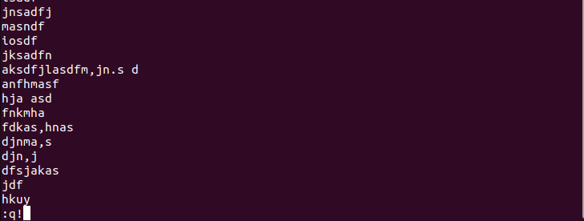
.

7.A person wishes to rename his tmux session with the name of his application.How could he rename his running tmux session?

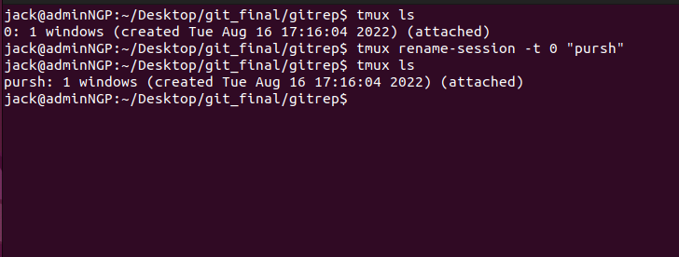
.
8.How to create a new tmux session in detach mode and run an application namely main.py.s
